STARAGILE DOCKER ASSIGNMENT -3

Step 1. Create and download a Spring Boot application with Spring Initializr.

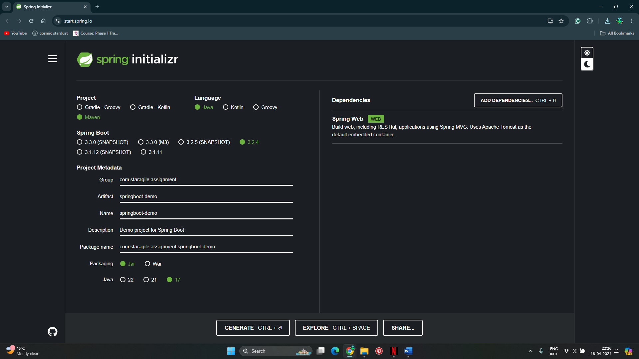

Step 2. Import the application into Eclipse or your preferred IDE.

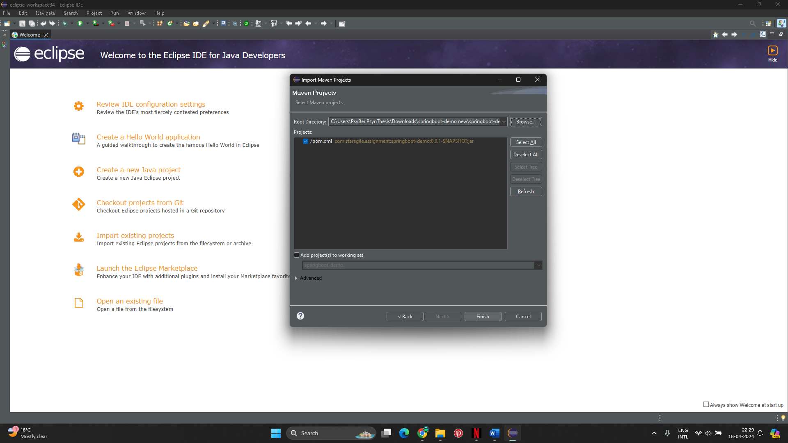

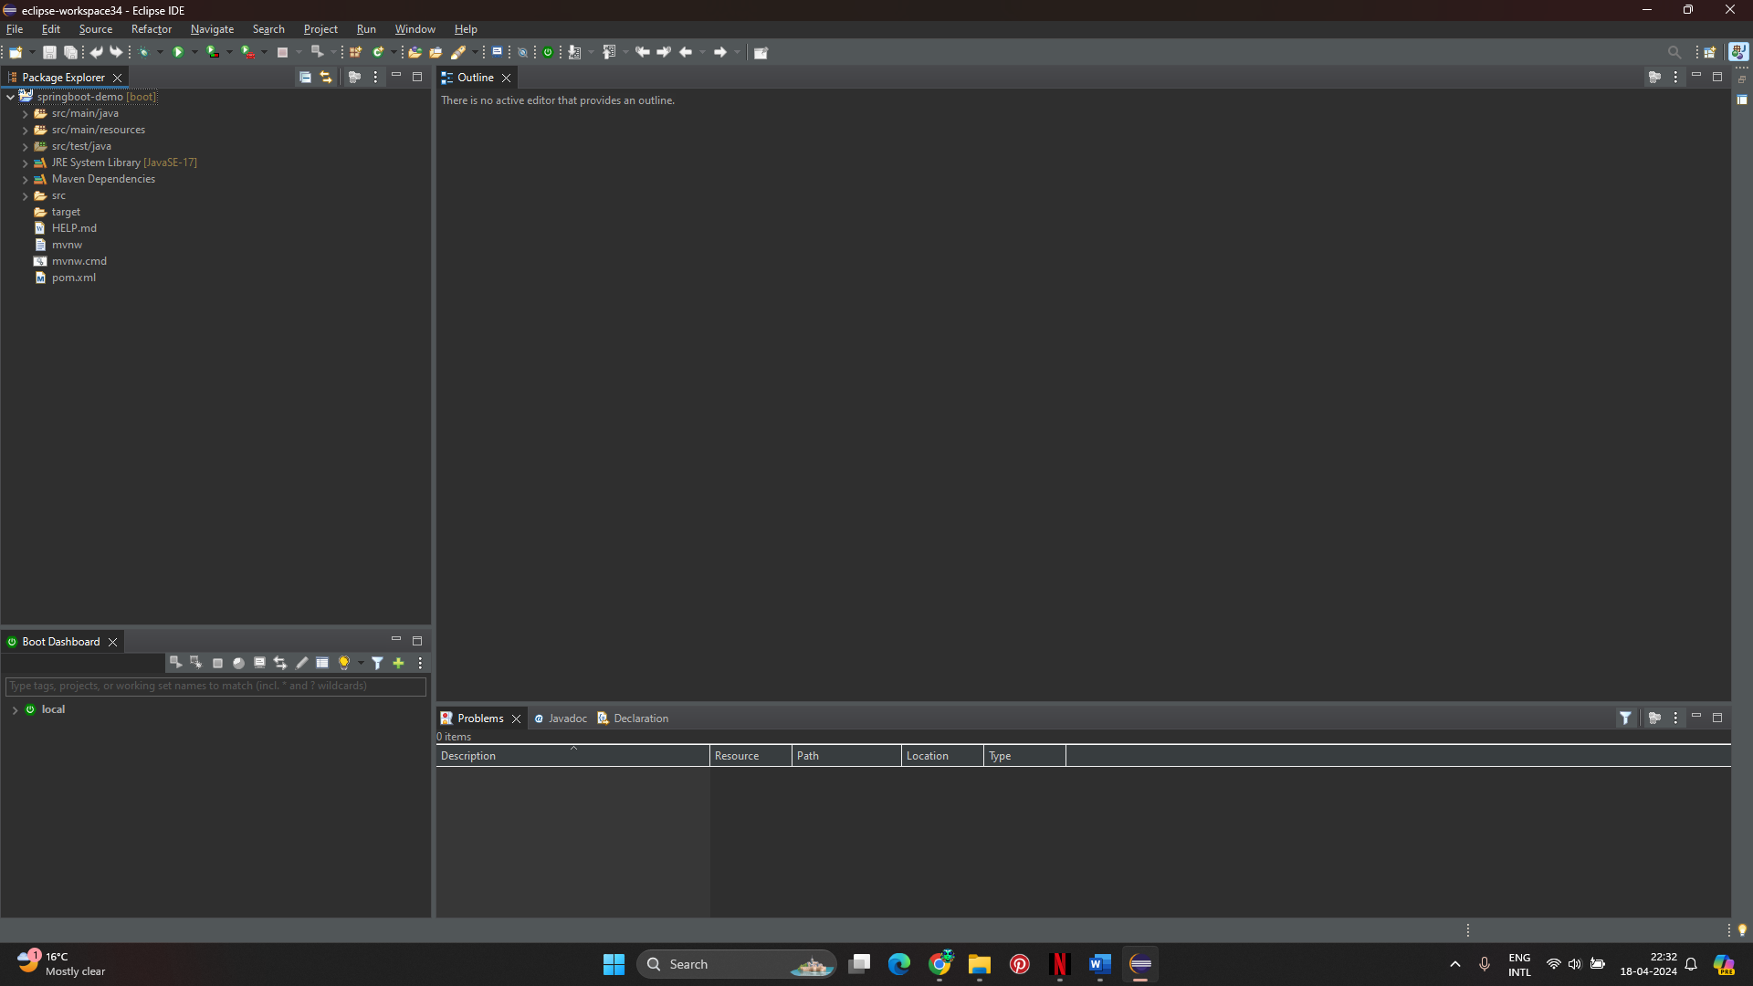

Step 3. Add an index.html to the main/resources/static folder. Add some test code on to it

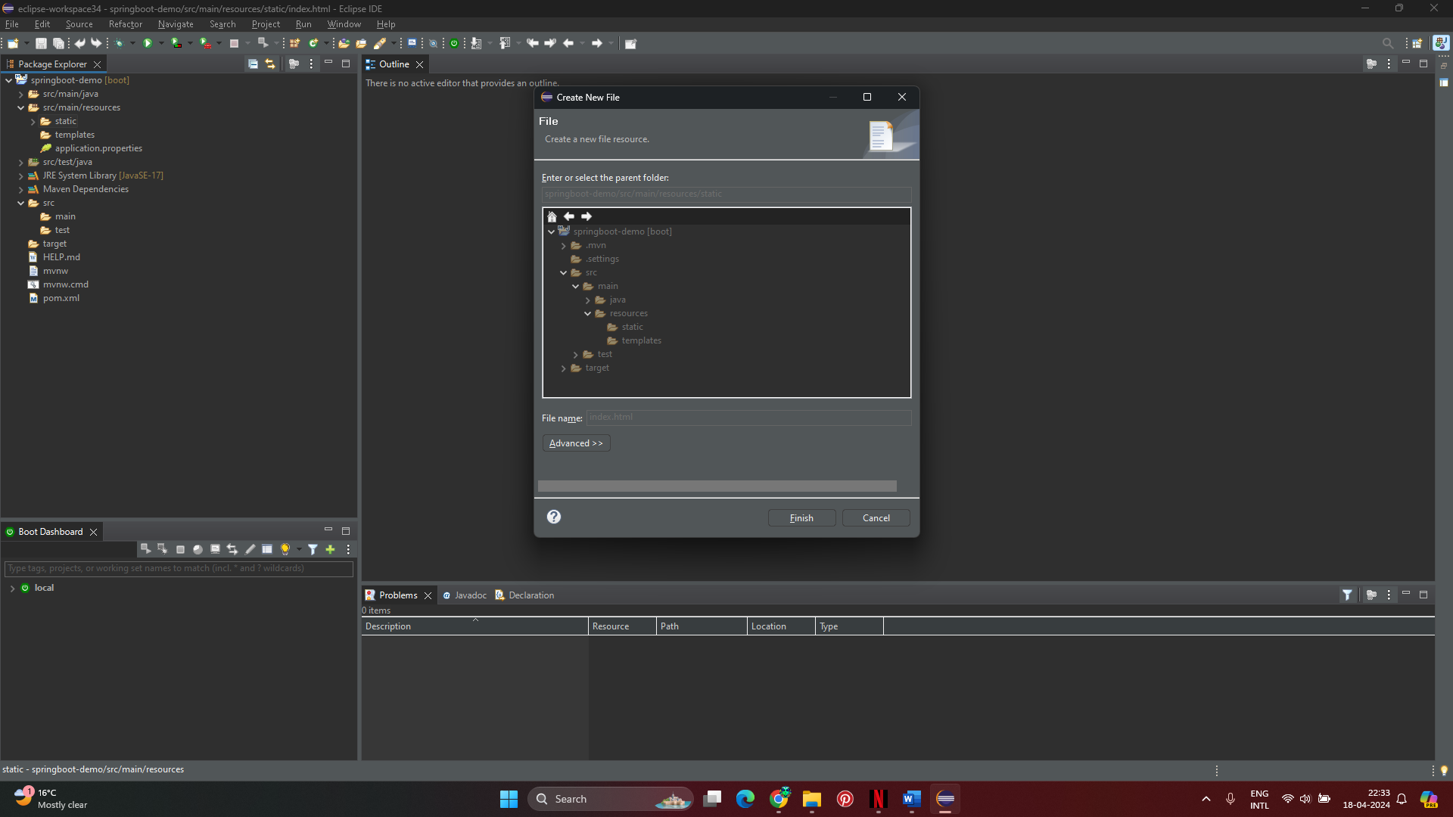

Step 4. Run and verify the application locally.

console

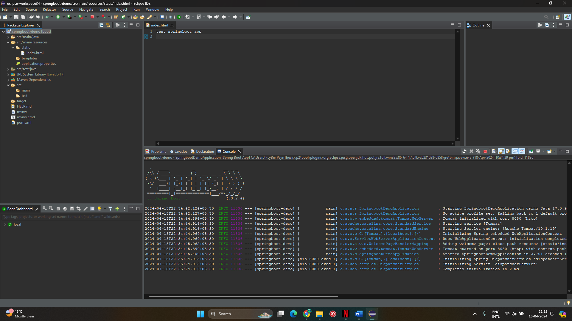

Browser

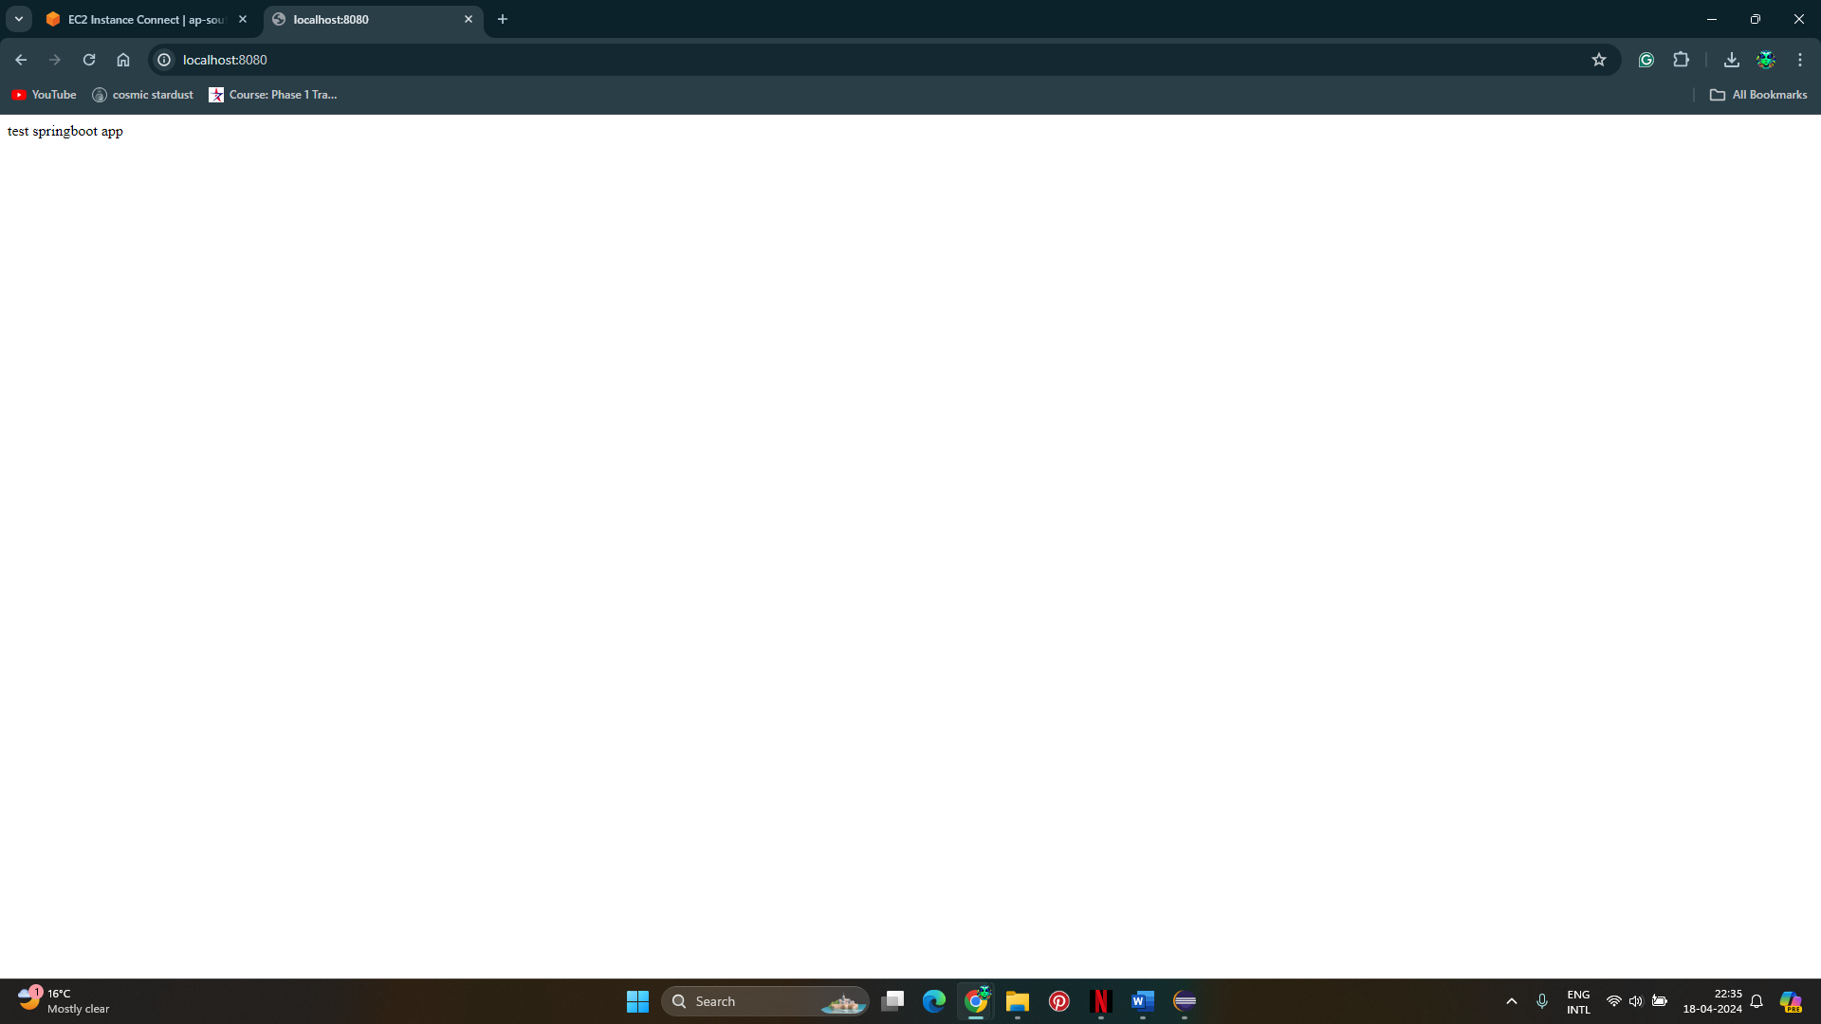

Step 5. Build the project and upload it to github

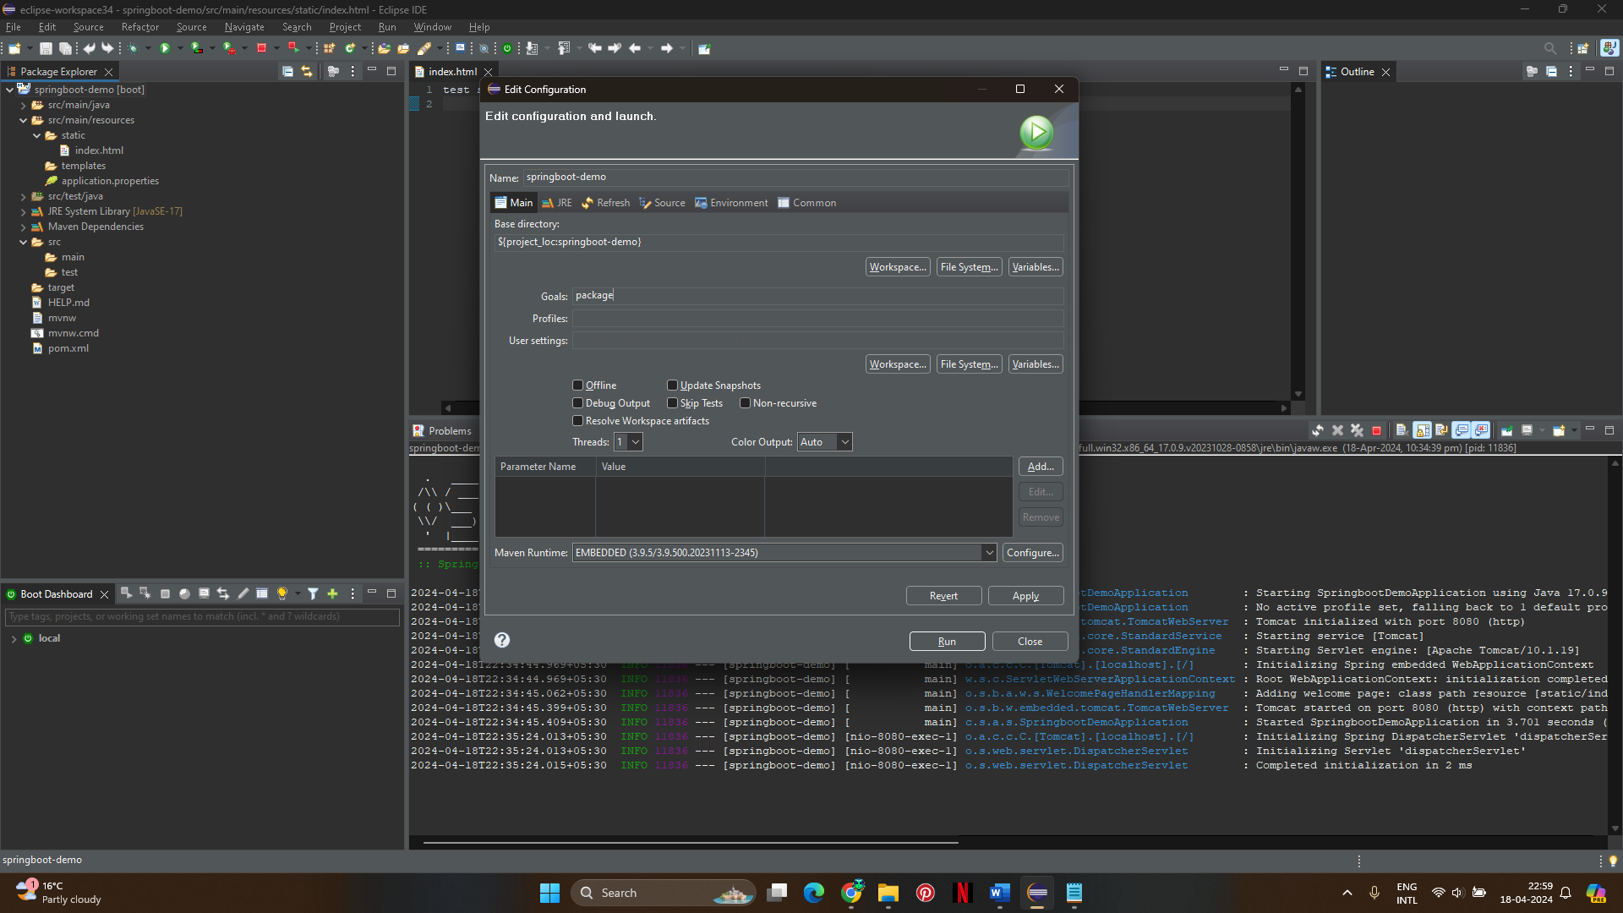

Step 6. clone the github project into the workspace

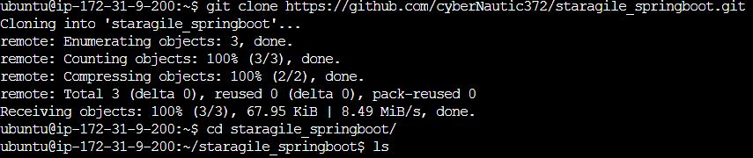

Step 7. Write a Dockerfile to containerize the application.

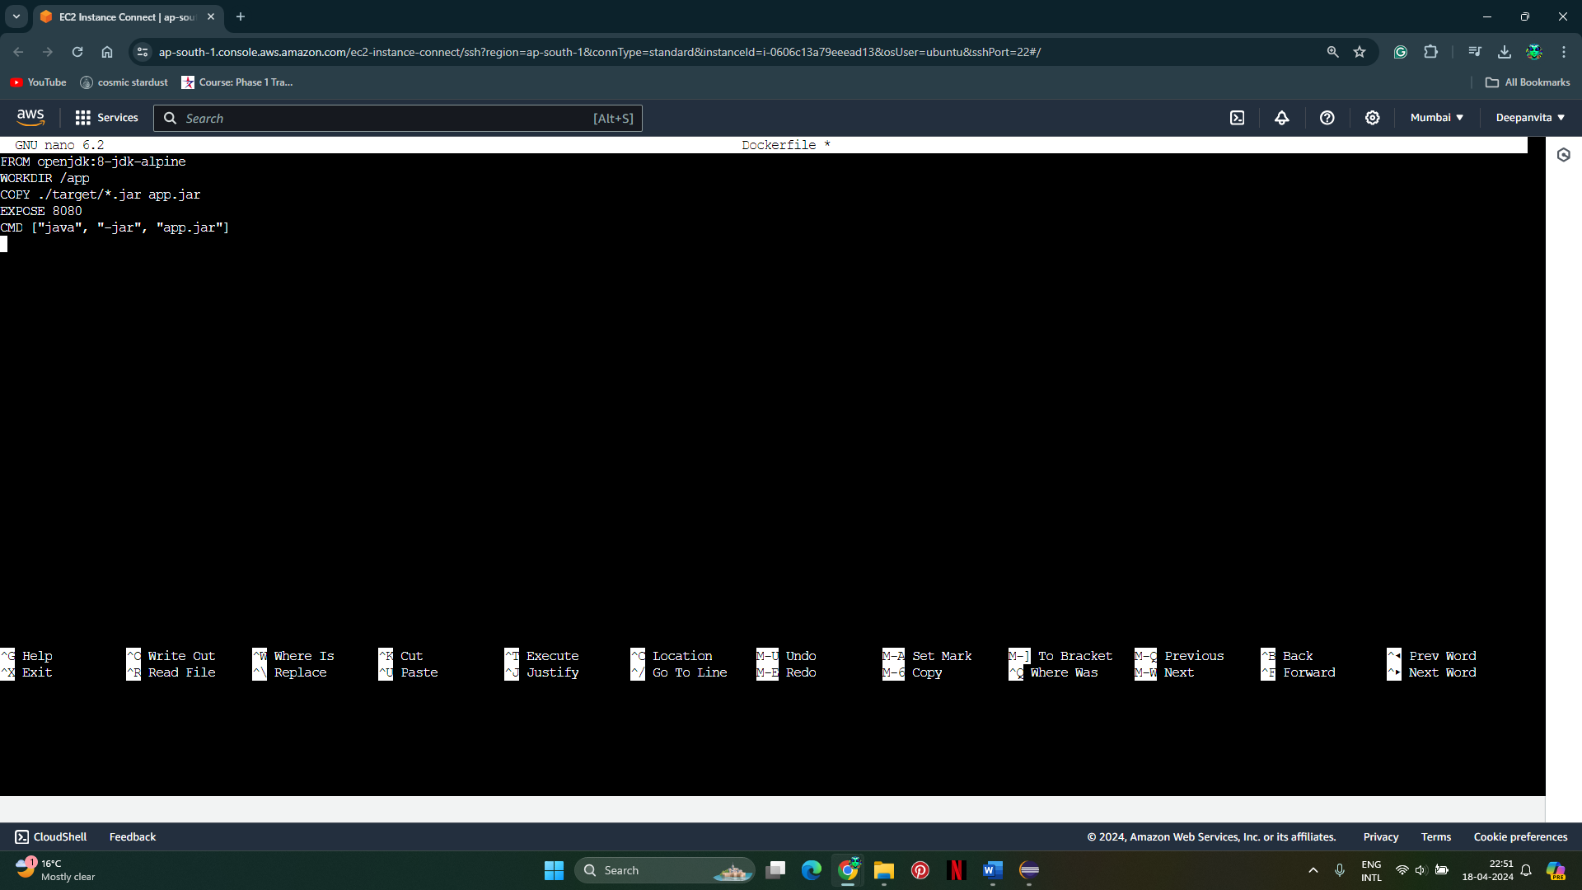

Step 8. Add Docker tag and Build the Docker image.

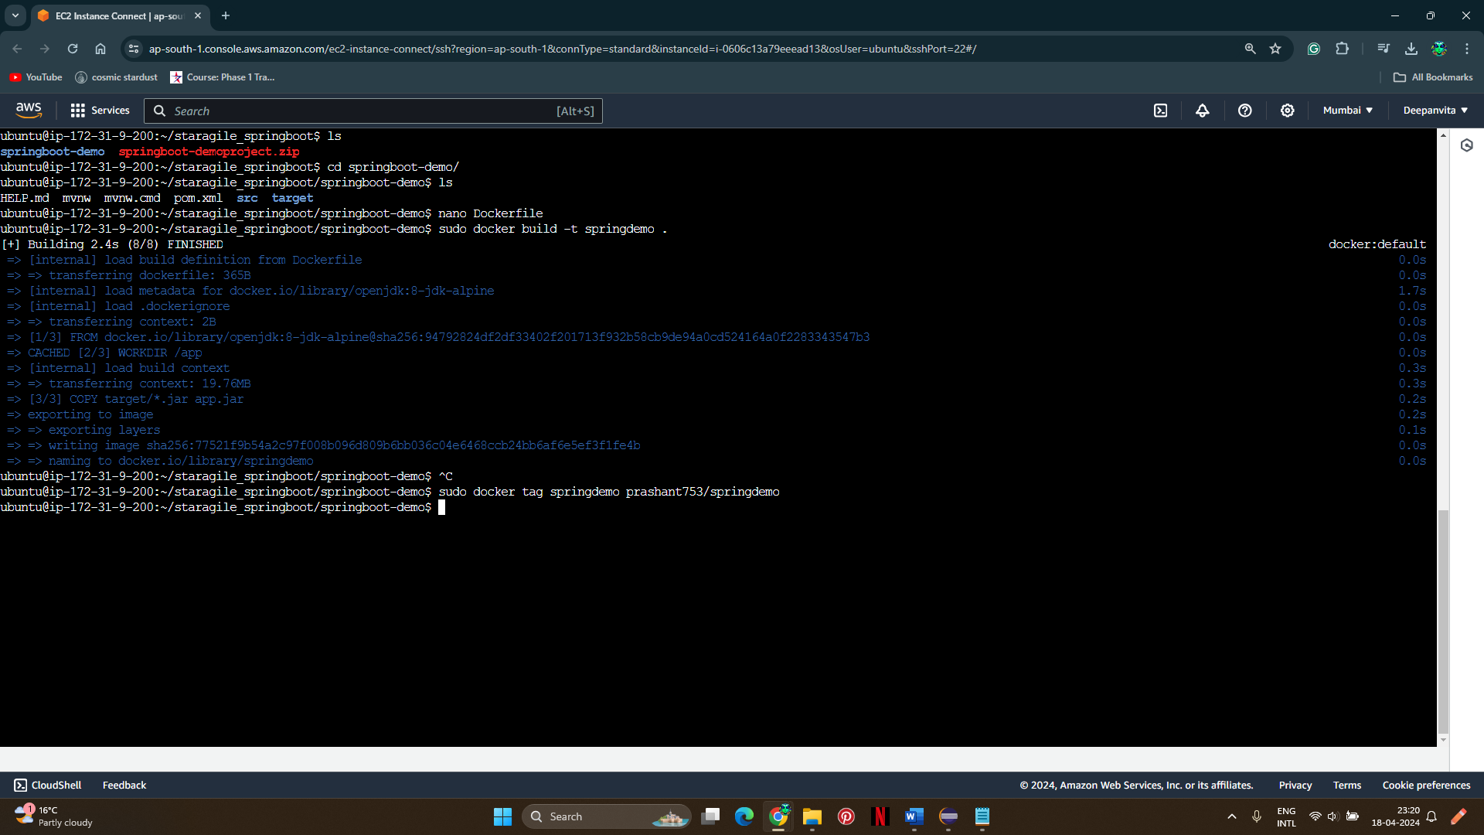

Step 9. Login to Docker HUB

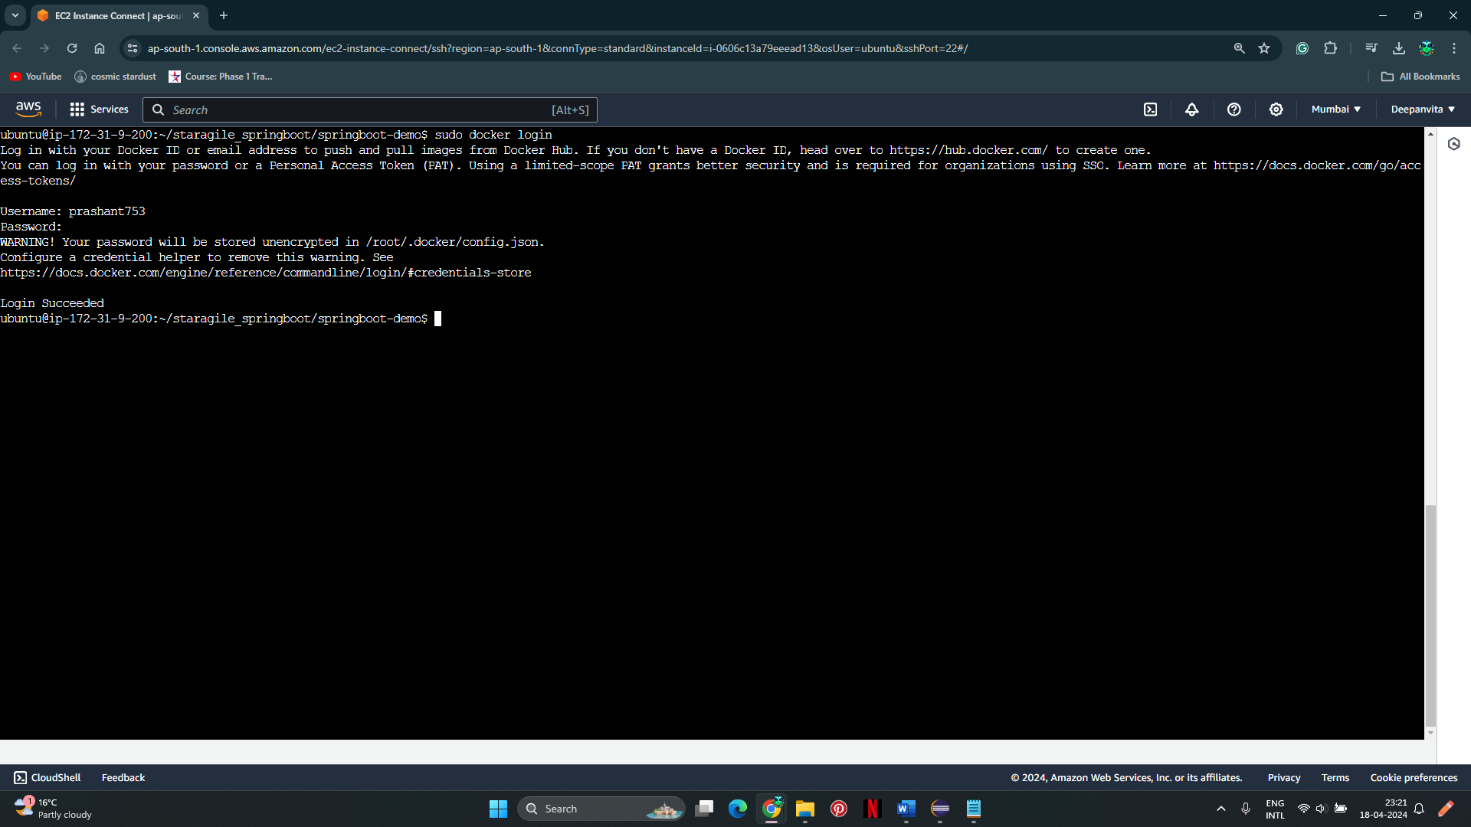

Step 10. Push the Docker image to Docker Hub

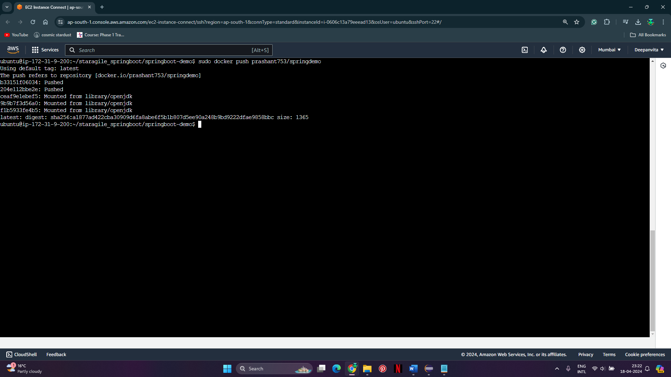

Verify pushing of the image

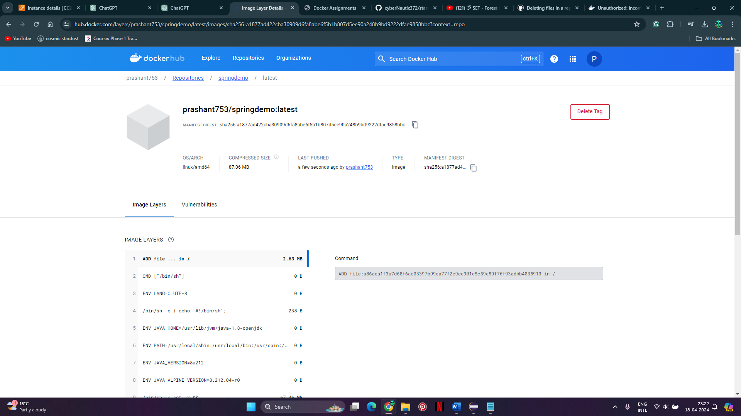

Step 11. Pull the Docker image onto your system.

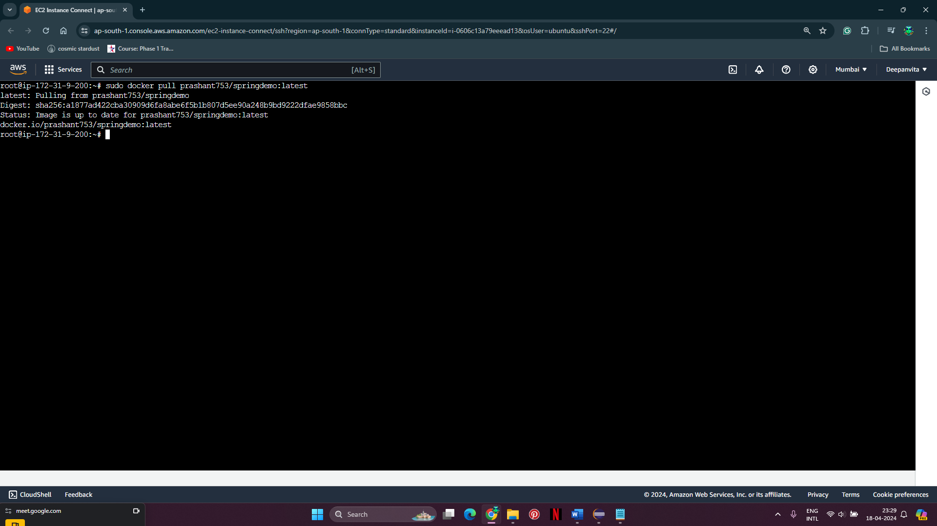

Step 12. Run the application as a container in detached mode and on system port 8089.

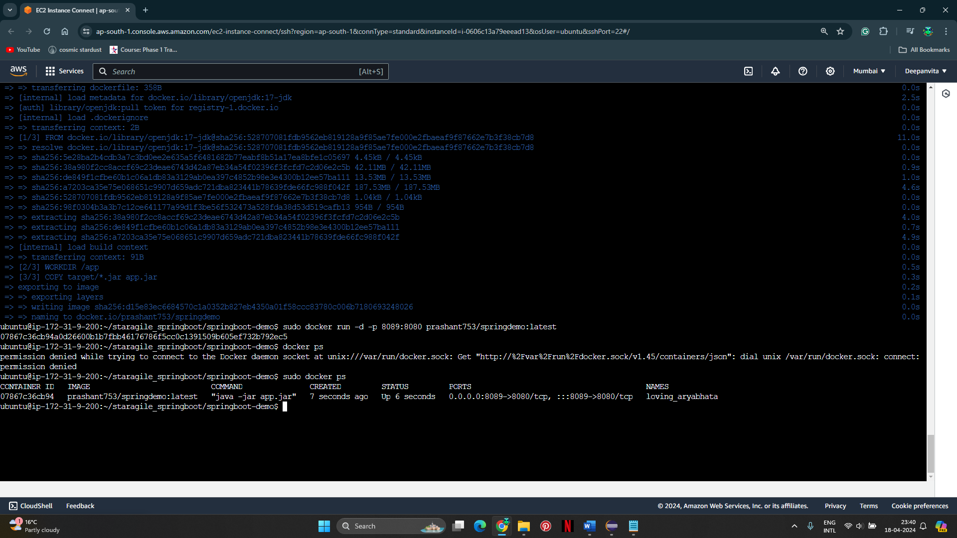

Verify on the browser if running

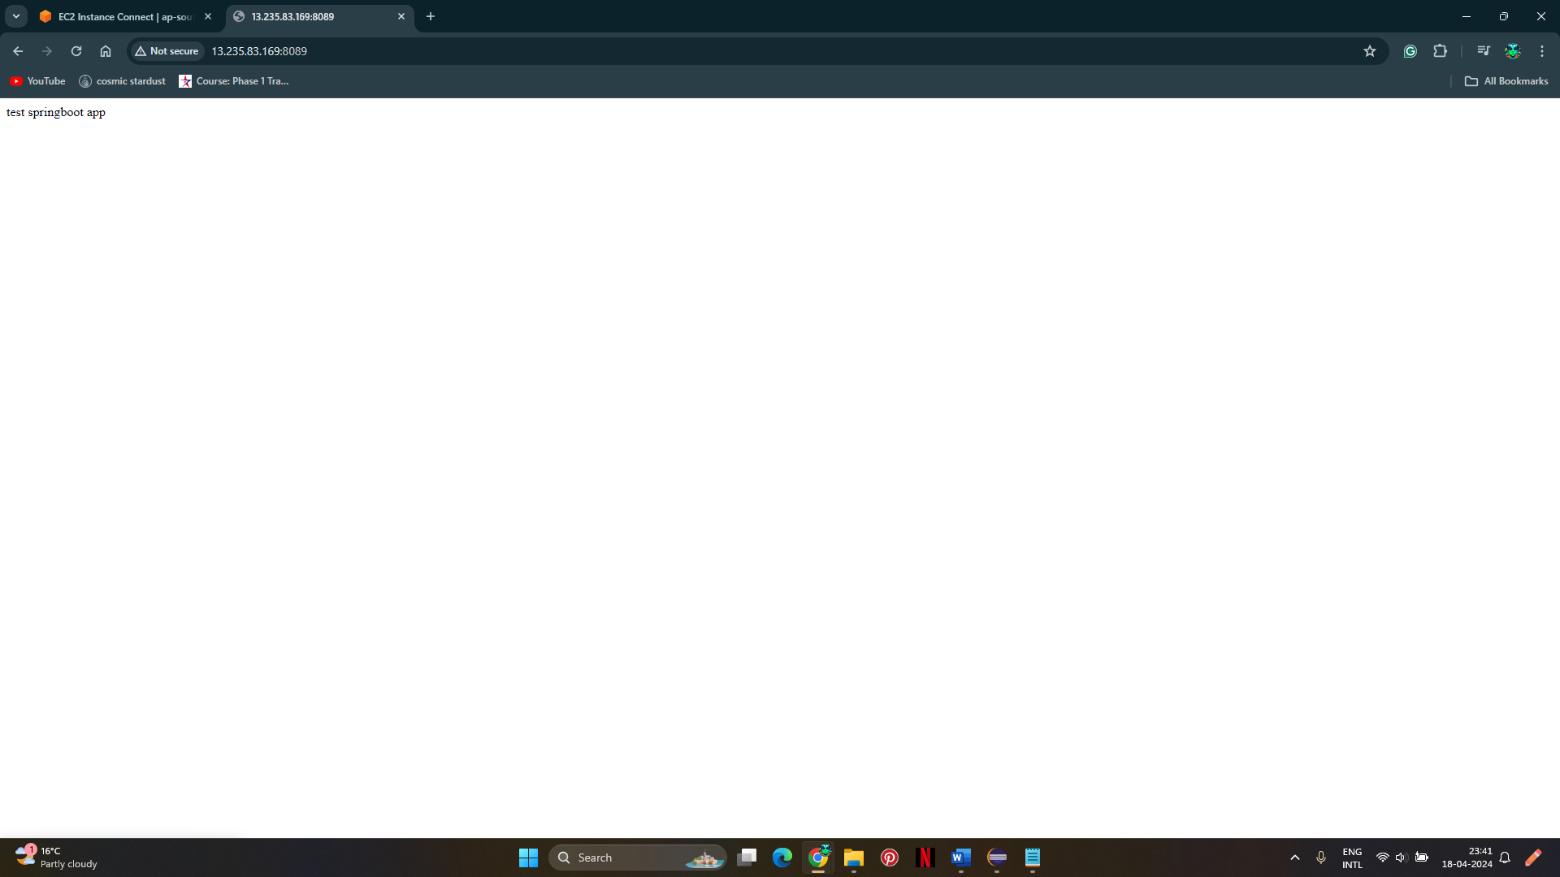

FYI, if there is any error in container not coming up check the java version while building and while running it is same in my case it was not correct so updated on the system and changed the docker file to use jdk 17  
